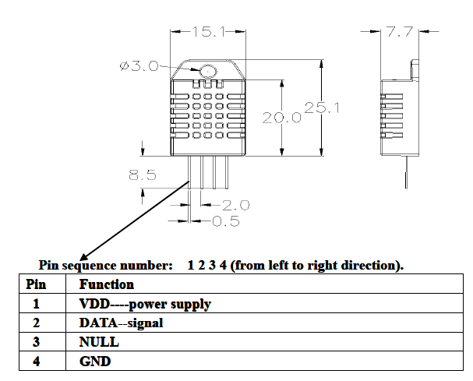**DHT22 Digital Temperature and Humidity Sensor**

The DHT22 has been chosen because of its low cost, precision and range of temperature/humidity. The sensor uses a capacitive humidity sensor and a thermistor to measure the surrounding air. A digital signal is sent to the data pin and no analog inputs are needed. This sensor requires careful timing for data due to the fact that new data can only be transmitted once every two seconds which should not be too big of a problem. This sensor requires 3.3-6V for power.

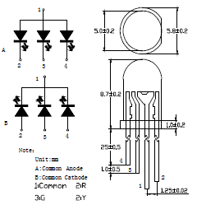

**5TSRGB-A/C LED**

This diffused 5mm tri-color LED has been chosen due to the size and simplicity. The LED is common-anode type therefore one pin in connected to 5V and the other three legs are tied to ground through a resistor. Red and blue on this LED will be used with correspondence to the temperature sensor to indicate hot/cold respectively. When the LED is emitting red, the max voltage used is 2.4V. As for blue, the max voltage is 3.6V.